Estimating Drivers of Cell State Transitions using Gene Regulatory Network Models

Daniel Schlauch[1,2], Kimberly Glass[2,3], Craig P. Hersh[2], Edwin K. Silverman[2,4], John Quackenbush[1,2,3]

[1]Department of Biostatistics and Computational Biology, Dana-Farber Cancer Institute and Department of Biostatistics, Harvard TH Chan School of Public Health, Boston, MA 02115 [2]Channing Division of Network Medicine, Brigham and Women’s Hospital, Boston, MA 02115 [3]Department of Medicine, Harvard Medical School, Boston, MA 02115 [4]Pulmonary and Critical Care Division, Brigham and Women’s Hospital and Harvard Medical School, Boston, USA

XXX

**Abstract**

Specific cellular states are often associated with distinct gene expression patterns. These states are plastic, changing during development, or in the transition from health to disease. One relatively simple extension of this concept is to recognize that we can classify different cell-types by their active gene regulatory networks and that, consequently, transitions between cellular states can be modeled by changes in these underlying regulatory networks. Here we describe MONSTER, **MO**deling **N**etwork **S**tate **T**ransitions from **E**xpression and **R**egulatory data, a regression-based method for inferring transcription factor drivers of cell state conditions at the gene regulatory network level. As a demonstration, we apply MONSTER to four different studies of chronic obstructive pulmonary disease to identify transcription factors that alter the network structure as the cell state progresses toward the disease-state. Our results demonstrate that MONSTER can find strong regulatory signals that persist across studies and tissues of the same disease and that are not detectable using conventional analysis methods based on differential expression. An R package implementing MONSTER is available at github.com/dschlauch/MONSTER.

## Introduction

Cell state phenotypic transitions, such as those that occur during development, or as healthy tissue transforms into a disease phenotype, are fundamental processes that operate within biological systems. Understanding what drives these transitions, and modeling the processes, is one of the great open challenges in modern biology. One way to conceptualize the state transition problem is to imagine that each phenotype has its own characteristic gene regulatory network, and that there are a set of processes that are either activated or inactivated to transform the network in the initial state into one that characterizes the final state. Identifying those changes could, in principle, help us to understand not only the processes that drive the state change, but also how one might intervene to either promote or inhibit such a transition.

Each distinct cell state consists of a set of characteristic processes, some of which are shared across many cell-states (“housekeeping” functions) and others which are unique to that particular state. These processes are controlled by gene regulatory networks in which transcription factors (and other regulators) moderate the transcription of individual genes whose expression levels, in turn, characterize the state. One can represent these regulatory processes as a directed network graph, in which transcription factors and genes are nodes in the network, and edges represent the regulatory interactions between transcription factors and their target genes. A compact representation of such a network, with interactions between *m* transcription factors and *p* target genes, is as a binary *p*×*m* “adjacency matrix”. In this matrix, a value of 1 represents an active interaction between a transcription factor and a potential target, and 0 represents the lack of a regulatory interaction.

When considering networks, a cell state transition is one that transforms the initial state network to the final state network, adding and deleting edges as appropriate. Using the adjacency matrix formalism, one can think of this as a problem in linear algebra in which we attempt to find an *m*×*m* “transition matrix” **T**, subject to a set of constraints, that approximates the conversion of the initial network’s adjacency matrix **A** into the final network’s adjacency matrix **B**, or

**B**=**AT**

In this model, the diagonal elements of **T** map network edges to themselves. The drivers of the transition are those off-diagonal elements that change the configuration of the network between states.

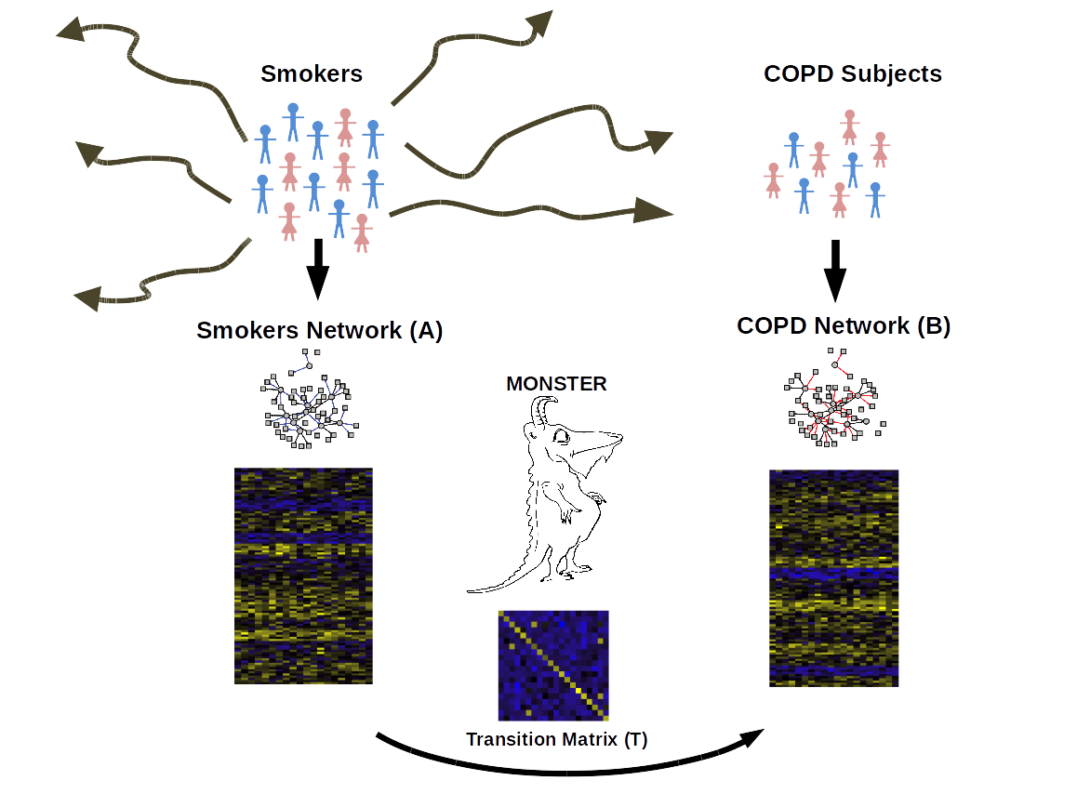

**Figure 1:** **Overview of the MONSTER approach, as applied to the transition between smokers and those suffering from chronic obstructive pulmonary disease (COPD).** MONSTER’s approach seeks to find the *TF*×*TF* transition matrix that best characterizes the state change in network structure between the initial and final biological conditions. Subjects are first divided into two groups based on whether they have COPD or are smokers that have not yet developed clinical COPD. Network inference is then performed separately on each and a transition matrix is computed which characterizes the conversion from the consensus Smokers Network to the COPD Network.

While this framework, as depicted in Figure 1, is intuitive, it is a bit simplistic in the sense that we have cast the initial and final states as discrete. However, the model can be generalized by recognizing that any phenotype consists of a collection of individuals or samples, all of whom have a slightly different manifestation of the state, and therefore a slightly different active gene regulatory network. Practically, what that means is that for each state, rather than having a network model with edges that are either “on” or “off,” a phenotype should be represented by a network in which each edge has a weight that represents an estimation of its presence across the population. In other words, the initial and final state adjacency matrices are not comprised of 1’s and 0’s, but of continuous variables that estimate population-level regulatory network edge-weights. Consequently, the problem of calculating the transition matrix is generalized to solving **B**=**AT**+**E**, where **E** is an *p*×*m* error matrix. In this expanded framework, modeling the cell state transition remains equivalent to estimating the appropriate transition matrix **T**, and then identifying state transition drivers based on features of that matrix.

**MONSTER: MOdeling Network State Transitions from Expression and Regulatory data**

The MONSTER algorithm models the regulatory transition between two cellular states in three main steps: (1) Inferring state-specific gene regulatory networks, (2) modeling the state transition matrix, and (3) computing the transcription factor involvement.

**Inferring state-specific gene regulatory networks:** Before estimating the transition matrix, **T**, we must first estimate a gene regulatory networks for each of our phenotypic states of interest. While there have been many methods developed to infer such networks [hill2012bayesian, eduati2012integrating, chen2009input, molinelli2013perturbation, saez2011comparing], we have found the bipartite framework used in PANDA [glass2013passing] to have features that are particularly amenable to interpretation in the framework of state transitions.

PANDA begins by using genome-wide transcription factor binding data to postulate a network “prior” , and then uses a message-passing approach to integrate multiple data sources, including state-specific gene coexpression data. Motivated by the approach used by PANDA, we developed a highly computationally-efficient, classification-based network inference method that uses common patterns between transcription factor targets and gene coexpression to estimate edges and to generate a bipartite gene regulatory network connecting transcription factors to their target genes.

This approach is motivated by the simple concept that genes that are affected by a common transcription factor and will exhibit expression patterns that correlate. To begin, we calculate the *direct evidence* for a regulatory interaction between a transcription factor and gene, which we define as the squared partial correlation between a given gene’s expression, *gi*, and the transcription factor’s gene expression, *gj*, conditional on all other transcription factors’ gene expression, *gk* :

,

where $g_{i}$ and $g_{j}$ are the gene expression patterns across the *N* samples and S represents the set of genes which are transcription factors.

We then use information about transcription factor targeting derived from sources such as ChIP-Seq or sets of known sequence binding motifs found in the vicinity of genes. In particular, we fit a logistic regression model which estimates the probability of each gene being a motif target of a transcription factor based the expression pattern across the *N* samples in each phenotypic class:

,

where the response $M_{i}$ is a binary vector of length *p* indicating the presence of a sequence motif for transcription factor *i* in the vicinity of each of the *p* genes. And where $g^{\left(q\right)}$ is a vector of length *p* specifying the gene expression for sample *q* over *p* genes. Thus, $e_{i,j}$ represents our indirect evidence. Combining the scores for the direct evidence, $d_{i,j}$, and indirect evidence, $e_{i,j}$, via weighted sum between each transcription factor-gene pair yields estimated edge-weights for the gene regulatory network (see Supplementary Materials and Methods).

Applying this approach to gene expression data from two distinct phenotypes results in two *p*×*m* gene regulatory adjacency matrices, one for each phenotype. These matrices represent estimates of the targeting patterns of the *m* transcription factors onto the *p* genes. This straightforward and computationally fast algorithm finds validated regulatory edges in *E. coli* and Yeast (*Saccharomyces cerevisiae*) datasets (see Supplementary Materials and Methods).

**Modeling the state transition matrix:** Once we have gene regulatory network estimates for each phenotype, we can formulate the problem of estimating the transition matrix in a regression framework in which we solve for the *m*×*m* matrix that best describes the transformation between phenotypes (see Equation XX). More specifically, MONSTER predicts the change in edge-weights for a transcription factor, *i*, in a network based on all of the the edge-weights in the baseline phenotype network.

$E\left[b_{i}−a_{i}\right]=τ_{1,i}a_{1}+⋯{+τ}_{m,i}a_{m}$,

where *bi* and *ai* are column-vectors in **B** and **A** that describe the regulatory targeting of transcription factor *i* in the final and initial networks, respectively.

In the simplest case, this can be solved with normal equations,

,

to generate each of the columns of the transition matrix **T** such that

$T=\left[τ_{1},τ_{2},⋯,τ_{m}\right]$.

The regression is performed *m* times corresponding to each of the transcription factors in the data. In this sense, columns in the transition matrix can be loosely interpreted as the optimal linear combination of columns in the initial state adjacency matrix which predict the column in the final state adjacency matrix. (see supplementary materials and methods).

This framework allows for the natural extension of constraints such as *L1* and/or *L2* regularization (see Supplementary Materials and Methods). For the analysis we present in this manuscript, we use the normal equations and do not impose a penalty on the regression coefficients.

**Computing the transcription factor involvement:** For a transition between two nearly identical states, we expect that the transition matrix would approximate the identity matrix. However, as the initial and final states diverge, there would be increasing differences in their corresponding gene regulatory networks and, consequently, the transition matrix will also increasingly diverge from the identity matrix. In this model, the transcription factors that most significantly alter their regulatory targets will have the greatest “off-diagonal mass” in the transition matrix, meaning that they will have very different targets between states and so are likely to be involved in the state transition process. We define the “transcription factor involvement” (dTFI) as the magnitude of the off-diagonal mass associated with each transcription factor, or,

,

where $τ_{i,j}$ is the value in of the element $i^{th}$ row and $j^{th}$ column in the transition matrix, corresponding to the $i^{th}$ and $j^{th}$ transcription factors and $I$ is the indicator function. To estimate the significance of this statistic, we randomly permute sample labels *n=1000* times across phenotypes (see Supplementary Materials and Methods).

## MONSTER finds significantly differentially involved transcription factors in COPD with strong concordance in independent datasets

As a demonstration of the power of MONSTER to identify driving factors in disease, we applied the method to case-control gene expression datasets from four independent Chronic Obstructive Pulmonary Disease (COPD) cohorts: Evaluation of COPD Longitudinally to Identify Predictive Surrogate Endpoints (ECLIPSE) (PMID 25265030), COPDGene (23590301), Lung Genomics Research Consortium (LGRC) [lgrc] and Lung Tissue Chronic Obstructive Pulmonary Disease (LTCOPD) [ltcopd]. The tissues assayed in ECLIPSE and COPDGene were whole blood and peripheral blood mononuclear cells (PBMCs), respectively, while homogenized lung tissue was sampled for LGRC and LTCOPD.

As a baseline comparison metric, we evaluated the efficacy of applying conventionally used network inference methods on these case-control studies. Commonly, networks are compared directly, with changes in the presence or weight of edges between key genes being of primary interest. If a method produces a reliable network for both diseased individuals and controls, one would hope that the differences between these networks would be reproducible across multiple independent studies. We investigated whether this is the case for our four COPD datasets using three commonly employed network inference methods - Algorithm for the Reconstruction of Gene Regulatory Networks (ARACNe), Context Likelihood of Relatedness (CLR), and Weighted Gene Correlation Network Analysis (WGCNA) - computing the difference in edge-weights between cases and controls for each of the four studies. Interestingly, we found no meaningful correlation $\left(R^{2}<.01\right)$ of edge-weight difference between any of the studies regardless of network inference method or tissue type (Supplementary Figure 1A-C). This suggests that a simple direct comparison of edges between inferred networks is insufficient for extracting reproducible drivers of network state transitions. This finding may be unsurprising given the difficulty in inferring individual edges in the presence of heterogeneous phenotypic states, technical and biological noise with a limited number of samples.

The lack of replication in edge-weight differences between independent datasets representing similar study designs indicates that we need to rethink how we evaluate network state transitions. MONSTER provides a novel approach for making that comparison. Along these lines, for each study, we applied MONSTER to calculate the differential transcription factor involvement (dTFI, see Equation XXX) for each transcription factor and used permutation analysis to estimate their significance (Figure 2, Supplementary Figure 3). We observed strongly significant $\left(p<1e-15\right)$ correlation in dTFI values for each pairwise combination of studies [See Supplementary Materials and Methods]. In addition, out of the top 10 most differentially involved transcription factors in the ECLIPSE and COPDGene studies, we found 7 in common. Furthermore, three of these seven transcription factors (GABPA, ELK4, ELK1) also appeared as significant in the LGRC results with FDR<0.01 and each of the top five ECLIPSE results were among the top seven in the LTCOPD results (Supplementary Table 2, Supplementary Figure 5).. This agreement is quite striking considering that the there was almost no correlation in the edge-weight differences across these same studies.



**Figure 2: MONSTER analysis results in the ECLIPSE study.** **A** Heatmap depicting the transition matrix calculated from smoker controls to COPD cases by applying MONSTER to ECLIPSE gene expression data. For the purposes of visualization, the magnitude of the diagonal is set to zero. **B** A network visualization of the strongest 100 transitions identified based on the transition matrix shown in (**A**). Arrows indicate a change in edges from a transcription factor in the Smoker-Control network to resemble those of a transcription factor in the COPD network. Edges are sized according to the magnitude of the transition and nodes (TFs) are sized by the dTFI for that TF. The gain of targeting features is indicated by the color blue while the loss of features is indicated by red. **C** The dTFI score from MONSTER (red) and the background null distribution of dTFI values (blue) as estimated by 1000 random sample permutations of the data.

Many of the top dTFI transcription factors, especially those identified by MONSTER in all studies, are highly relevant for COPD [Supplementary Table 2, Supplementary Figure 5]. For example, E2F4, is a transcriptional repressor important in airway development (17383628). Recent work has pointed to the relevance of developmental pathways in COPD pathogenesis (26681127). Additionally, we observed some of the highest effect sizes for SP1 and SP2 in the four studies. An additional member of the Sp transcription factor family, Sp3, has been shown to regulate HHIP, a known COPD susceptibility gene (22140090). Both of SP1 and SP2 have been found to form complexes with the E2F family [Rotheneder 1999, Karlseder J 1996] and may play a key role in the alteration of E2F4 targeting behavior. Furthermore, E2F4 has been found to form a complex with EGR-1 (a highly significant transcription factor in ECLIPSE and LTCOPD) in response smoke exposure, which may lead to autophagy, apoptosis and subsequently to development of emphysema [Chen 2008].

Additionally, research has identified mitochondrial mechanisms associated with COPD progression [cloonan2016mitochondrial]. It is therefore noteworthy that the two most highly significant transcription factors based on dTFI in the ECLIPSE study were NRF1 and GABPA (FDR<.001). These TFs had highly significant differential TF involvement (FDR<0.1) in all four studies. NRF1 regulates the expression of nuclear encoded mitochondrial proteins (7629110). GABPA, also known as human nuclear respiratory factor-2 subunit alpha, may have a similar role in nuclear control of mitochondrial gene expression]. Furthermore, GABPA interacts with SP1 [galvagni2001sp1] providing evidence of a potentially shared regulatory mechanism with E2F4.

Overall, we found a strong correlation across studies in transcription factors identified as significantly differentially involved (Figure 3A-3B). It is reassuring that we find the strongest agreement when comparing studies that assayed similar tissues. However the fact that the we see similar dTFI signal across studies involving different tissue types is also of note. Gene regulatory networks derived from gene expression data are notoriously difficult to replicate across studies (PMC2831005) and it is of great interest that we have identified transcription factors whose regulatory mechanisms are suspected to play a role in COPD across multiple studies, including those assaying different tissues.

There are many aspects that are specific to each of the four studies we used in our analysis, including microarray platform, study demographics, location, time and tissue. MONSTER largely identified similar sets of transcription factors when defining the transition between cases and controls based on COPD diagnosis vs. smoking non-COPD patients. However, some transcription factors had different levels of dTFI in the different studies. For example, in the LGRC dataset, we discovered a highly significant (FDR<.0001) differential targeting pattern involving the transcription factors RFX1 and RFX2 [Supplementary Table 2]. However, these same TFs were not identified as potential drivers of the Smoker Control to COPD transition in either the ECLIPSE or COPDGene study - likely due the differences in tissue type. Transcription factors in the RFX family are known to regulate ciliogenesis (choksi2014switching). This process is critical for clearing mucous from the airways in healthy lung tissue, but when disrupted can lead to infection and chronic obstruction (hessel2014intraflagellar, hogg2004pathophysiology, fahy2010airway).

Our hypothesis is that transcription factors that alter their targets (and therefore have high dTFI scores) are drivers of changes in phenotypic state. It would be reasonable to suspect that these transcription factors would differ across cases and controls at the transcriptional level. Therefore, we compared dTFI to differential expression in ECLIPSE (Figure 4, other studies in Supplementary Figure 5). However, many of the transcription factors with high dTFI were not differentially expressed in these studies. This suggests that there may be other mechanisms, including epigenetic, phosphorylation and protein interaction factors, affecting the structure of gene regulatory networks and that the master regulators of phenotypic state change may have differentiated targeting behavior in patients in the COPD group compared to the control group.

These results demonstrate the scientific value of MONSTER. Numerous biologically established results were found across several independent studies. The reproducibility of the top transcription factor is compelling. We demonstrate that these findings would not have been possible via differential gene expression analysis or conventional comparative network inference methods.



**Figure 3: Strong reproducibility in differential transcription factor involvement (dTFI) found across multiple case-control COPD studies**. ECLIPSE and COPDGene data were obtained from whole-blood and PBMC while the gene expression data in LGRC and LTCOPD were assayed in lung tissue. (**A**) Results for studies with gene expression data obtained from the same-tissue. Both the blood-based (left) and lung tissue studies (right) demonstrate very high spearman correlation of differential involvement. (**B**) Despite using data from different sources we still found agreement between studies of different tissues.

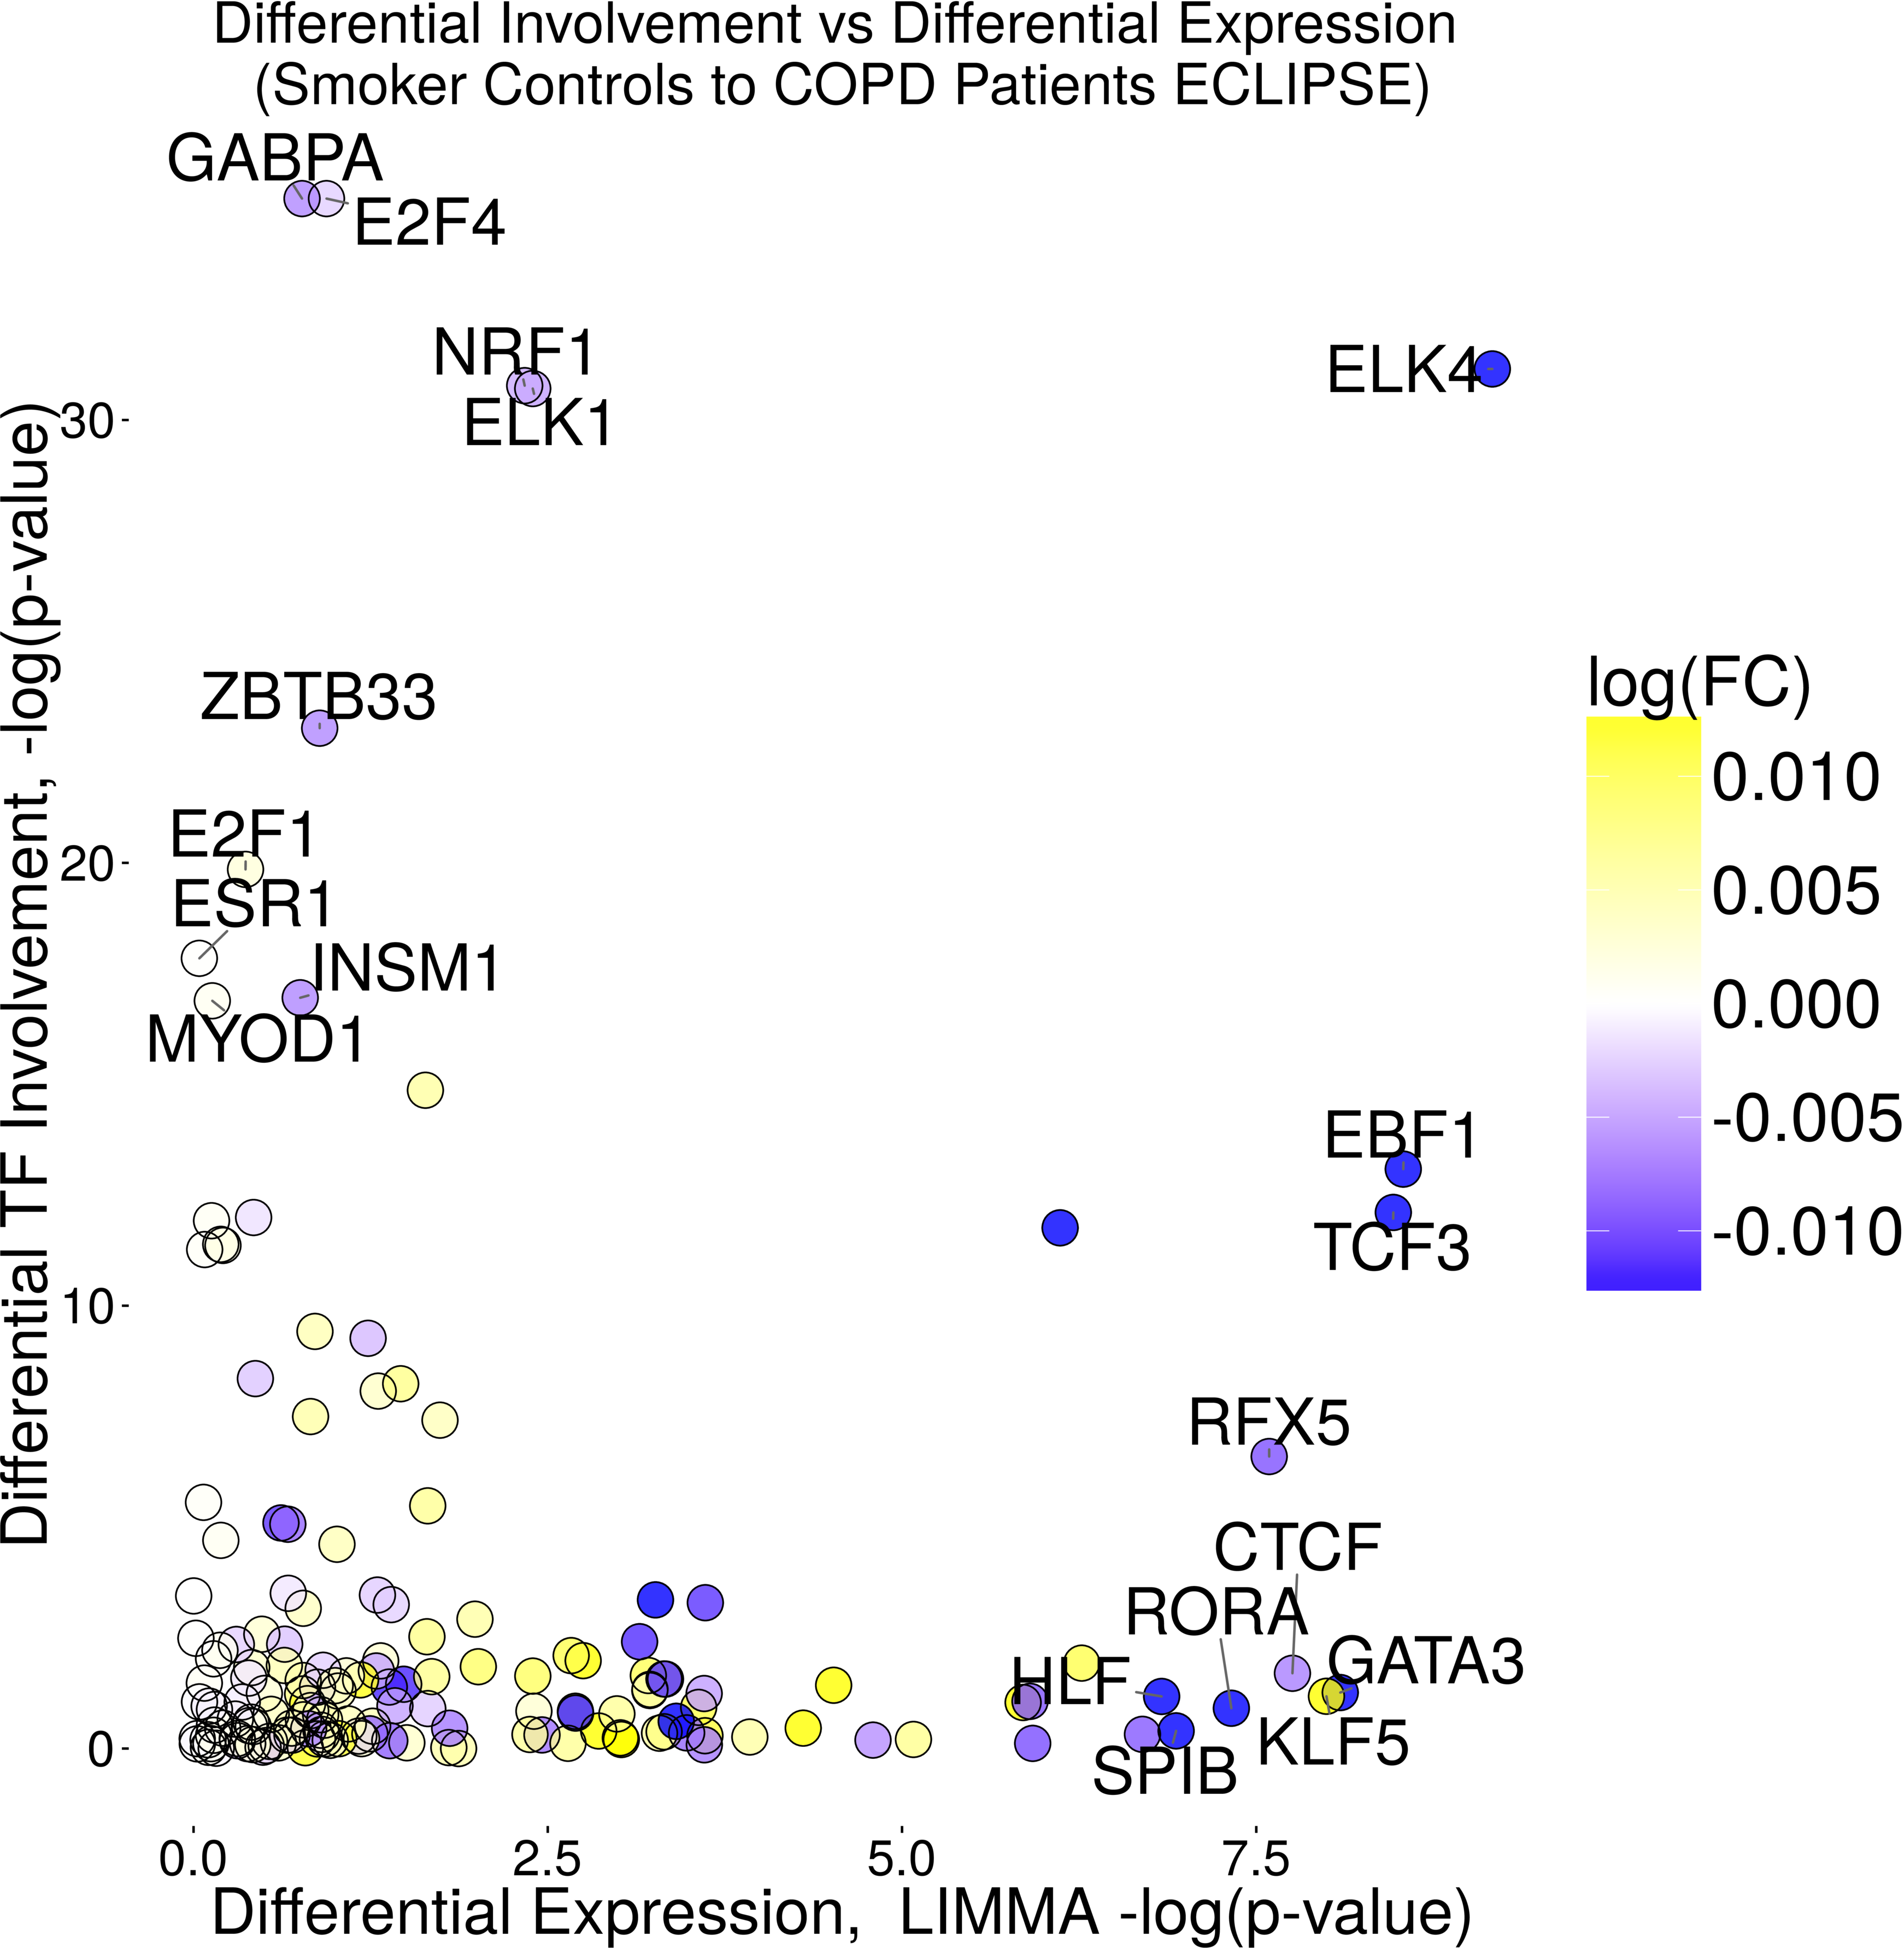

Figure 4: **Differentially involved transcription factors are not necessarily differentially expressed.** MONSTER commonly finds transcription factors which are differentially involved but are expressed at similar levels across cases and controls. This change in involvement suggests that network rewiring occurs at a post-transcriptional stage. Importantly, these transcription factors would not have been identified using conventional differential expression methods.